Name _________________________________ AP Calculus
3-16 HW: Section 3.9: Derivatives of Exponential and Logarithmic Functions

Show all your work!! * Indicates a graphing calculator question.

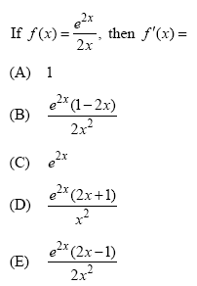
1.

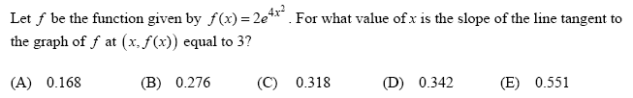
*2.

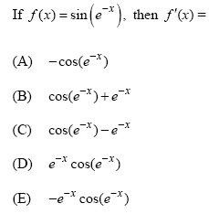
3.

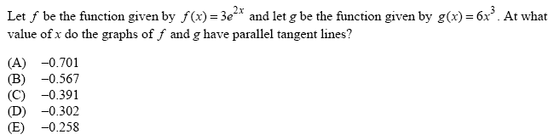
*4.

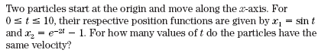
*5.

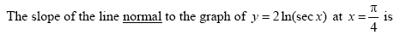
6.

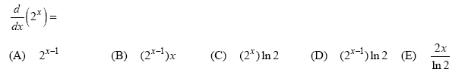
7.

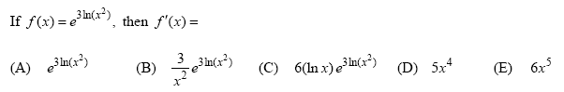
8.

